Test Case Template With Explanation | Software Testing Material

A **test case template** is a document comes under one of the test artifacts, which allows testers to develop the test cases for a particular test scenario in order to verify whether the features of an application are working as intended or not. Test cases are the set of positive and negative executable steps of a test scenario which has a set of pre-conditions, test data, expected result, post-conditions and actual results.

Most of the companies are using test case management tools such as Quality Center (HP QC), JIRA etc., and some of the companies still using excel sheets to write test cases.

Check the below video to watch “How To Write Test Cases Manually”

Here are some test cases.

1. Enter valid User Name and valid Password  
2. Enter valid User Name and invalid Password  
3. Enter invalid User Name and valid Password  
4. Enter invalid User Name and invalid Password

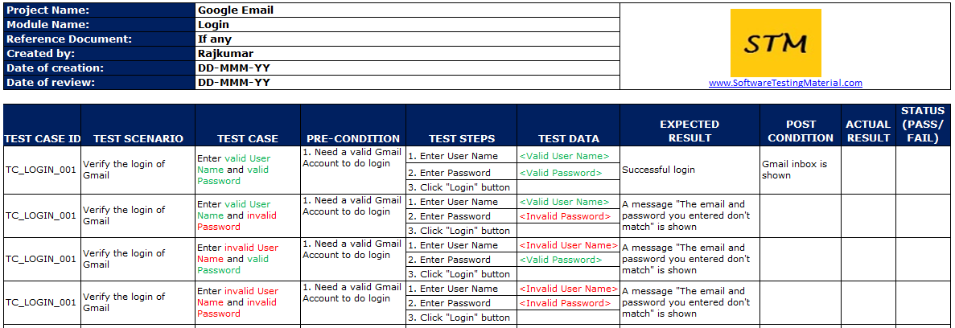Find the test case template screenshot below:

Let’s discuss the main fields of a test case:

**PROJECT NAME:** Name of the project the test cases belong to  
**MODULE NAME:** Name of the module the test cases belong to  
**REFERENCE DOCUMENT:**Mention the path of the reference documents (if any such as Requirement Document, [Test Plan](https://www.softwaretestingmaterial.com/test-plan/), Test Scenarios etc.,)  
**CREATED BY:** Name of the Tester who created the test cases  
**DATE OF CREATION:** When the test cases were created  
**REVIEWED BY:**Name of the Tester who created the test cases  
**DATE OF REVIEW:**When the test cases were reviewed  
**EXECUTED BY:** Name of the Tester who executed the test case  
**DATE OF EXECUTION:** When the test case was executed  
**TEST CASE ID:** Each test case should be represented by a unique ID. It’s good practice to follow some naming convention for better understanding and discrimination purpose.  
**TEST SCENARIO:** Test Scenario ID or title of the test scenario.  
**TEST CASE:** Title of the test case  
**PRE-CONDITION:** Conditions which needs to meet before executing the test case.  
**TEST STEPS:** Mention all the test steps in detail and in the order how it could be executed.  
**TEST DATA:** The data which could be used an input for the test cases.  
**EXPECTED RESULT:** The result which we expect once the test cases were executed. It might be anything such as Home Page, Relevant screen, Error message etc.,  
**POST-CONDITION:** Conditions which needs to achieve when the test case was successfully executed.  
**ACTUAL RESULT:** The result which system shows once the test case was executed.  
**STATUS:** If the actual and expected results are same, mention it as Passed. Else make it as Failed. If a test fails, it has to go through the [bug life cycle](https://www.softwaretestingmaterial.com/bug-life-cycle/) to be fixed.